**Life Recipe**(14pt Time **Title of Your Work** (14pt Times New Roman)

(영어 이름) (11pt Times New Roman)

Green-apple(Choroksagwa), Korea, e-mail (10.5pt Times New Roman)

Abstract

Here you write the overview of your product. The length of the abstract should be 200-300 words. In the beginning of the abstract, the subject of the paper should be stated clearly, together with its scope and objectives. Then, the methods, equipment, results and conclusions in the paper should be stated concisely in a sufficiently logical manner. (10pt Times New Roman)

The mechanism behind can be divided into hardware and software aspect: in terms of software, Cartographer Algorithm(used for mapping), YOLO V3 Algorithm(used for object identification in visual function) and AMCL Algorithm(used for navigation) are applied to realize four functional modules; in the aspect of hardware, single-line lidar(used for navigation), infrared sensor and depth-camera(used for automatic following) are adopted to fulfill different requirements of functions. With the couple of software and hardware, the successful object identification achieves considerable accuracy as well as the rate of completing task successfully, which prove the high reliability and practicality of the design.

사용된 프로그램, 언어, 기능 등 설명

사용자의 편리를 위해, 웹 프로그램을 디자인하게 되었다. 언어는 주로 JAVA와 HTML(JSP)를 사용하였다. 웹 페이지의 외관적인 면은 HTML언어로 작성되었고, 내부적인 기능(데이터베이스 등)은 JAVA언어로 작성되었다. 데이터베이스에 저장되는 정보는 회원정보(아이디, 비밀번호, 성별 등)와 게시글 정보(제목, 내용, 작성일 등)이다.

Note: This is a sample template for proceeding. Please follow the format within two pages.

Background & Purpose

Here please state the background, purpose, and subject of your product briefly. (10pt Times New Roman)

Currently, the price of labor force is considerably high especially in developed countries, which makes the outlay of labor force account for large parts in logistics industry expanse and poses increasing burden on industry development. Consequently, creating an effective logistics car which is able to guarantee operating efficiency is compulsory. Specifically, the logistics car ought to be intelligent enough to carry out different tasks, efficient enough to create profits.

라이프레시피는 삶 속에서 잊을 수 있을 만큼 사소하지만, 또 중요한 일상적 상식들을 설명하는 웹 프로그램이다. 이 프로그램을 작성하게 된 계기는, 개발하기 위한 아이템을 찾던 중 한 팀원이 일상적인 상식을 모아 찾아볼 수 있는 프로그램이 있으면 좋겠다는 말에 아이디어를 얻어 프로그램을 제작하게 되었다. 구체적으로 장례식장에서의 예의, 옷차림, 제사 순서 등을 예로 들 수 있다.

Concept & Idea

Here please explain the concept and idea of your product in detail. (10pt Times New Roman)

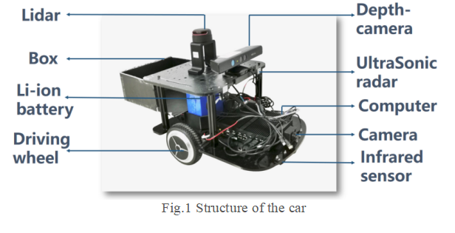The overall structure of the design is showed in the Fig.1. The car is designed on an idealized platform and series of accurate sensors is installed to fulfill multiple functions. Specifically, lidar (a sensor that can transmit laser to all directions) is able to effectively detect nearby environments. Depth-camera is aimed to detect accurately in short distance and identify some key characteristics of obstacle like person. Infrared sensor is utilized to detects relatively short distance (no more than 1m) in quick response and maintain safety distance from obstacle. Camera is used to capture front images by visual function.The sensors coordinate with each other to complete the task.

이 프로그램은 로그인과 회원가입, 메인페이지, 게시판으로 이루어져 있다. 구체적으로 회원가입 시에는 이름과 성별, 아이디 비밀번호, 이메일을 입력해야 한다. 메인페이지에서는 ~~~한 기능이 있다. 게시판은 로그인을 해야 이용 가능한 기능인데, 게시판의 글이 10개가 넘어가면 페이지를 이동할 수 있다. 또 각 세시물의 제목과 작성일 등을 간단하게 볼 수 있으며 글을 클릭하면 (글 작성자라면)수정과 삭제 또한 가능하다.

Design & Functions

Here please explain the design and function of your product in detail. (10pt Times New Roman)

A factory-simulated environment is established to launch the simulation of real-world factory transportation, which shows the process of autonomous transportation by this car. The simulated process is divided into several parts which display functional modules.

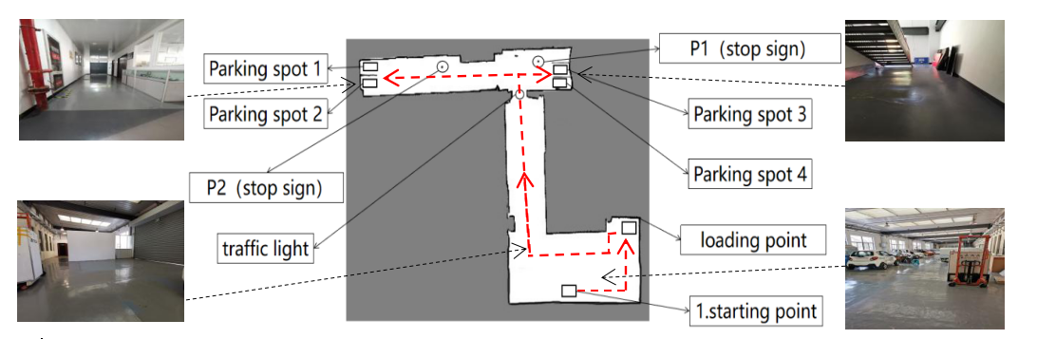Function 1(Mapping): The intelligent car utilizes lidar to transform the real scene into a 2-D map. This 2-D map(Fig. 2) is the transformation of simulated scene by using Cartographer Algorithm.

웹 페이지 이미지에 따라 설명

Fig. 2 The simulated 2-D map

Function 2(Visual function): The car utilizes Convolutional Neural Networks for environment detection. Four kinds of signs are selected in the simulated scene, such as traffic light and parking sign. Then the car is trained with the YOLO V3 Algorithm to equip it with visual capacity, laying the foundation of automatic following and navigation.

Function 3(Automatic Following): The car utilizes depth-camera and infrared sensor to identify and follow the worker to loading point, in which process the car realizes collision avoidance and speed adjustment automatically. After recognizing people successfully by adopting human-body recognizing algorithm in depth-camera(Fig. 3), the car starts to follow automatically.

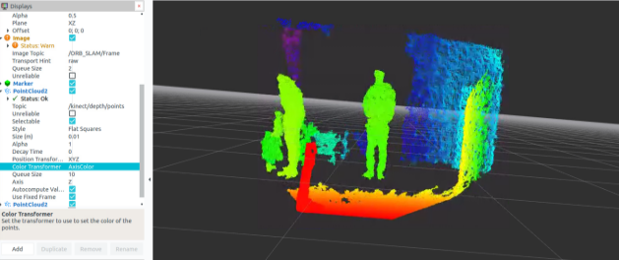

Fig. 3 The depth information from depth-camera

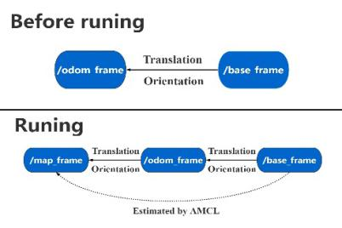Function 4(Navigation): After loading goods, the car is going to transport these goods to destination autonomously. Based on the 2-D map established by Function 1, AMCL Algorithm is utilized to analyze datasets, create relationship between frames(Fig. 4) and give out the prediction of the car’s current pose. Simultaneously, the car analyzes the environment information and feedback from visual system mentioned in Function 2 to achieve route self-planning, realizing navigation and complete the autonomous transportation finally.

1. Fig. 4 The relationship between frames

Problems & Future work

Here please state problems to solve in your future work simply. (10pt Times New Roman)

Four functional modules have been integrated in the logistics car with employing numbers of fashioned algorithms. Some of the algorithms have the potential to be polished, leading to better performance. What’s more, testing environment also has the potential to be improved by adding more complexity, by which more faults could be found to optimize the design.

아직까지 목표로 하는 기능이 구현이 안되었기 때문에, 기능구현을 제1 목표로 삼고 갈 것이다. 구현할 기능은 구체적으로 카테고리 기능, 검색 기능이다. 두 기능이 추가되면 전체적으로 사용자가 이용하기 편리해질 것이다.